PORTFOLIO

DATA ANALYST
&
FOOTBALL PERFORMANCE

THOMAS GUIBERT

Data Analyst – Football, Performance & Career Development
Audencia & Centrale Nantes – Data Science & AI

📧 th om a sgu ib er t.etu d es@ g m a il.co m
📱 +33 7 68 09 17 39
🔗 linkedin.com/in/thomas-guibert-big-data

PROFESSIONAL PROFILE

Data analyst specializing in football performance, injury prevention and player valuation. Trained in Data Science, Statistics and AI (Audencia x Centrale Nantes), I use data to support:

Football clubs
- Sporting directors
- Performance & medical staff
- Match analysts
- Player agents (en dernier)
My expertise: quantifying player progression, securing transfers, assessing return-to-play readiness, identifying performance factors, and building data-driven player profiles.
I also work on performance monitoring, match-related data analysis, workload indicators, injury-risk modelling and functional profiling — areas directly relevant to performance departments and match analysis units within professional clubs.

Value for a club — Performance & Match Analysis
- Monitoring of physical and functional performance
- Identification of performance trends over time
- Data-driven support for return-to-play decisions
- Analysis of workload, asymmetries and risk indicators
- Visualisation dashboards for staff meetings
- Benchmarking of players within the squad
- Support for match analysis (event data, simple tracking insights)
- Clear communication of insights to coaches and performance staff

Value for a player agent
- Objectively track a player’s progression after injury
- Provide data-driven arguments for negotiations
- Secure transfers with reliable, evidence-based insights

- Identify functional strengths and weaknesses
- Benchmark a player against performance standards
- Build a compelling, data-enhanced player profile
- Monitor a player’s evolution over several months

SHORT ANALYSIS — DATA & FOOTBALL
NEWS

When Alisson Becker Scores from a Corner: A Historic Premier League Moment
This analysis follows the approach recommended by a StatsPerform Data Scientist: producing short, reactive, football-related content to showcase analytical skills.
On May 16, 2021, Alisson Becker (Liverpool) scored a header in the 95th minute against West Bromwich Albion, from a corner kick.
This goal became historic because:
  - First headed goal ever scored by a goalkeeper in Premier League history
  - First Liverpool goalkeeper to score in an official match
  - Scored in the 95th minute, with Champions League qualification at stake
  - Occurred on an offensive corner with the goalkeeper joining the attack

Why is this analytically interesting?
  - Goals scored by goalkeepers are extremely rare
  - The match context explains the high-risk decision
  - The analysis can explore:
    - Historical frequency of goalkeeper goals
    - Tactical context of late-game goalkeeper involvement
    - Profiles of goalkeepers capable of scoring
    - Psychological impact and momentum shifts

Analytical value: This type of event connects data, tactical context and storytelling — a highly appreciated format in football analytics.

ADVANCED PROJECTS — ANALYSIS &
VISUALIZATION
These projects were completed in 2024–2025, after my internship at Kinesport. They reflect a more advanced level in data science, visualization and football analytics.

Heatmap — Spatial Analysis (Python)

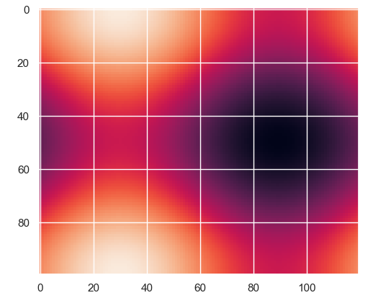
Objective: Analyze the spatial distribution of an indicator (intensity, danger, activity, etc.) on a modeled pitch grid.

Skills used:
  - 2D matrices, interpolation
  - Advanced visualization (Matplotlib / Seaborn)
  - Data normalization
  - Spatial analysis applied to football

Value for clubs / analysts: Helps visualize zones of influence, activity or danger for a player or a team. This type of spatial modelling can be applied to event data or tracking data to analyse zones of influence, pressing patterns or positional tendencies.

Python Animation — Spatiotemporal Movement Generation

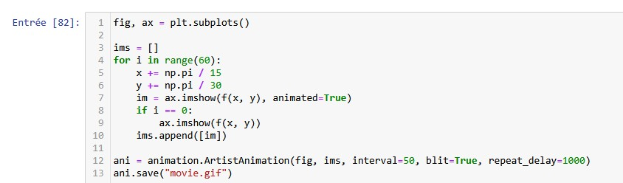

Objective: Create a dynamic animation illustrating the evolution of a phenomenon (movement, intensity, trajectory) over time.

Skills used:
  - Python (Matplotlib Animation)
  - Frame-by-frame image generation
  - Manipulation of evolving matrices
  - Construction of analytical GIFs

Value for clubs / analysts: Useful for representing tracking-data sequences, collective movements or tactical evolutions. This approach can be used to illustrate player movements, collective behaviours or tactical sequences based on tracking data.

MATCH ANALYSIS — ANALYTICAL APPROACH
Objective: Explore match-related data to identify patterns, tendencies and key actions relevant to coaches and analysts.
Skills used:
  - Identification of key actions and patterns
  - Simple event-data exploration (passes, shots, recoveries)
  - Visualisation of positional tendencies
  - Linking physical and tactical indicators
  - Clear reporting for coaches

Familiar with the analytical logic behind event data (passes, shots, recoveries, sequences) and with the structure of tracking-based spatial and temporal analyses used in professional clubs.
Value for clubs: Provides actionable insights for match analysis units, supports tactical discussions, and helps connect physical performance with on-field behaviours.

TECHNICAL SKILLS

Languages & Tools
Python (Pandas, NumPy, Matplotlib, Seaborn, Statsmodels, Scipy) Jupyter Notebook – SQL – Power BI – Advanced Excel

Statistics & Data Science
Statistical tests (T-test, Chi², ANOVA, Pearson) Regression models – Post-hoc analyses – EDA – Advanced visualization Machine learning preparation (neural networks)

Data Pipeline
Cleaning & merging – Missing-value handling Feature construction – Descriptive analysis – Modeling

Football & Field Expertise
10 years of competitive football — Regional 1 level Occitanie Champion Strong knowledge of functional tests: Single Hop, Triple Hop, Side Hop, Crossover Hop, Illinois, ACL-RSI… Personal experience with ACL rupture (2023) On-field performance analysis

EDUCATION — KEY COURSES & GRADES

Technical Courses (Audencia x Centrale Nantes)
Scientific Python (Informatics I → VI) — 16 to 18/20
Mathematics (Analysis, Algebra, Probability & Statistics) — 17 to 18/20 Data Analysis & Business Intelligence — 12.7/20
Data Mining — 16/20
Machine & Deep Learning — 15.3/20 Natural Language Processing — 13.8/20 Scientific Visualization — 15.6/20
Cloud Computing — 16/20

Semester in Shenzhen (China) Blockchain & Business Analytics — 19/20 Introduction to Fintech — 18.4/20 Chinese Language — 20/20
Internet of Things — 15.8/20

CASE STUDY — BIG DATA ANALYSIS OF THE
KSTARTS TEST

Kinesport / Medinetic Learning — 11Stadium (Lyon) Role: Data Scientist Intern
Case study completed at the end of my first year. My skills have since evolved through advanced coursework in years 2 and 3.

Objective

Analyze 2,088 tests, 266 variables and 550,000+ data points to:
- Assess a player’s ability to return to previous performance levels
- Identify factors influencing functional performance
- Support return-to-play, recruitment or transfer decisions
- Provide data-driven arguments to enhance player valuation

KEY RESULTS

Side Hop is the strongest predictor of post-ACL performance Heatmap of KSTARTS correlations
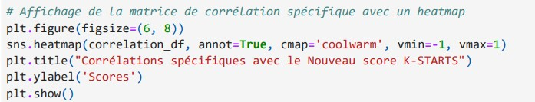

Psychological readiness (ACL-RSI) directly influences return-to-play Correlations between functional tests and the KSTARTS score (ACL-RSI: 0.28)
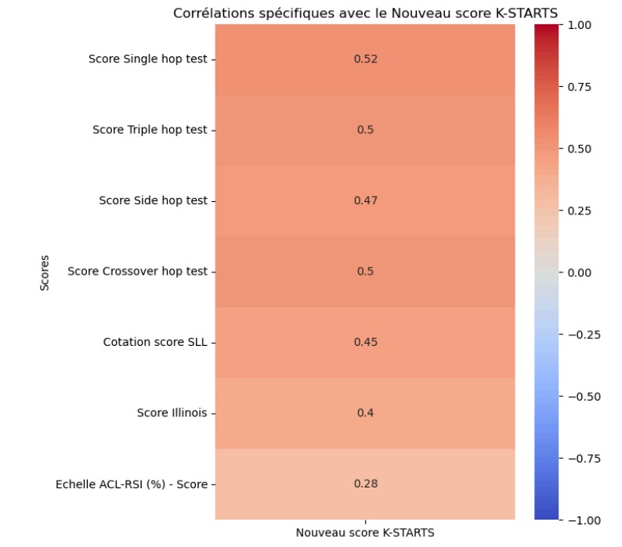
→ The psychological factor (ACL-RSI) shows a moderate correlation (0.28) with the KSTARTS score: psychologically ready players statistically tend to return faster and stronger. These insights support performance departments, medical teams and S&C coaches in
return-to-play decisions and functional monitoring.

Heatmap (7 tests)

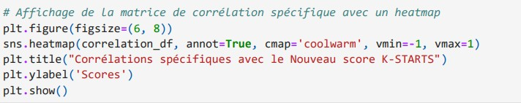

Male players achieve significantly higher scores Boxplot — Sex vs KSTARTS Score
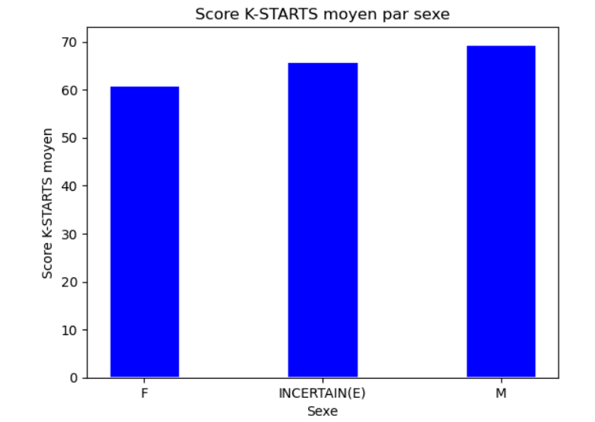

→ Helps adjust expectations based on player profile.

Genu valgum is a major negative factor Boxplot — Genu Valgum vs KSTARTS Score
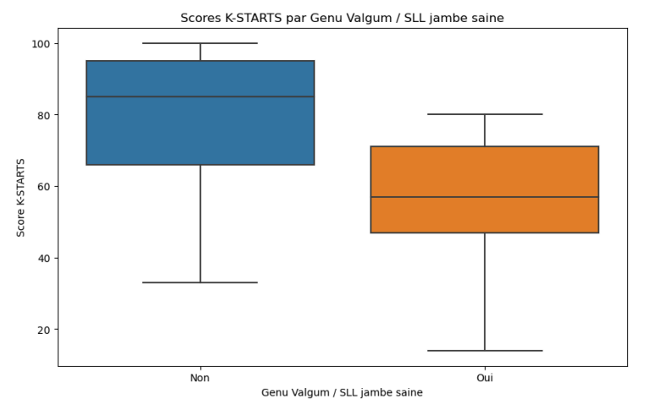
→ Players without valgum have a functional advantage — useful to reassure clubs about biomechanical stability.

Playing level influences functional performance Pivot table — Playing Level vs KSTARTS Score
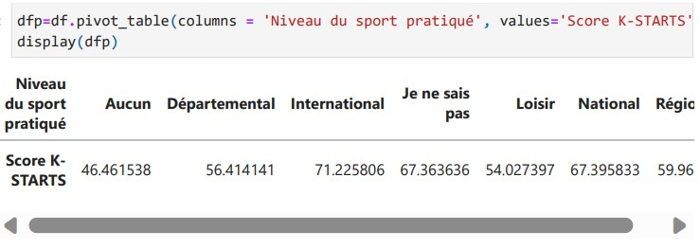
→ Higher-level players perform better — useful for benchmarking.

Number of rehabilitation sessions correlates with final score Scatterplot — Sessions vs KSTARTS Score
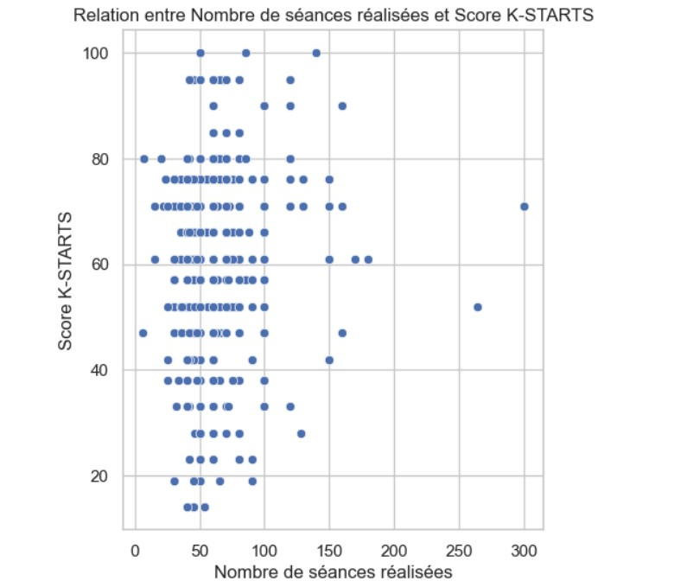
→ More consistent rehabilitation leads to faster progression — a strong argument to demonstrate a player’s commitment.

VALUE FOR PLAYER AGENTS

To enhance player valuation
  - Highlight functional strengths
  - Provide clear visuals for player dossiers
  - Compare players to performance standards

To secure transfers
  - Objective analysis of return-to-play
  - Identification of residual risks
  - Reliable data to reassure clubs

To support career management
  - Longitudinal performance monitoring
  - Identification of progression areas
  - Construction of a complete data-driven profile

METHODOLOGY — DATA PIPELINE

Pipeline diagram

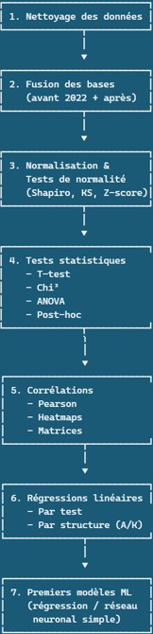

STATISTICAL ANALYSES
Normality analysis
QQ Plot + Illinois Score Histogram

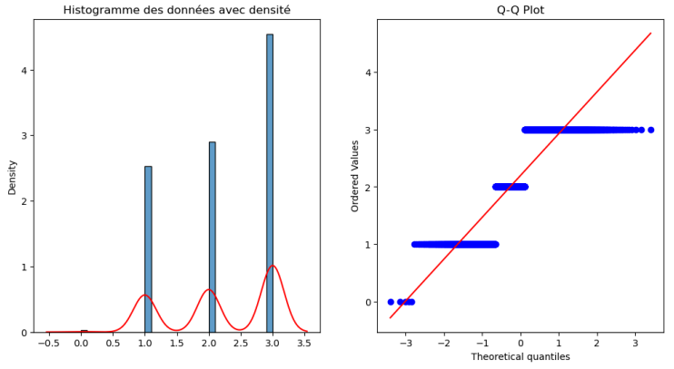
→ Justifies statistical choices.

Linear regressions
Regression — Illinois Score → KSTARTS Score

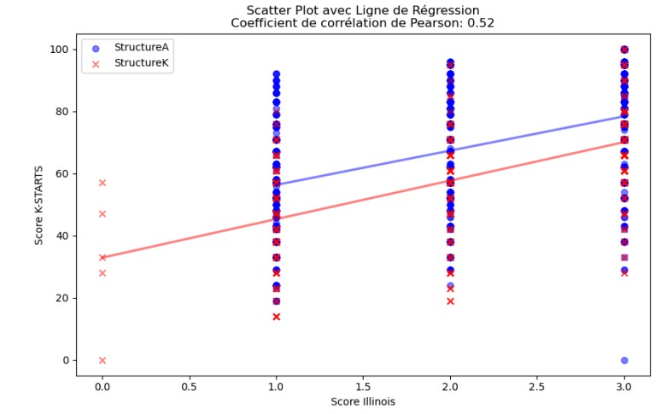

→ Agility is a strong predictor of performance.

ANOVA
Boxplot — Off-axis plyometric work

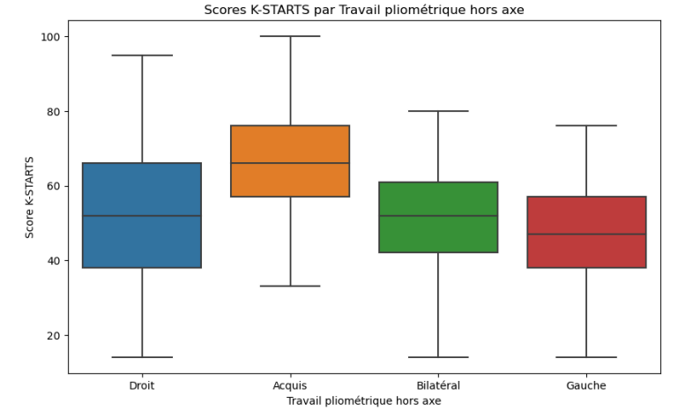
→ Shows the influence of training type on performance.

VISUAL ANNEX
  - Histograms: Weight / Age / Height / Sessions

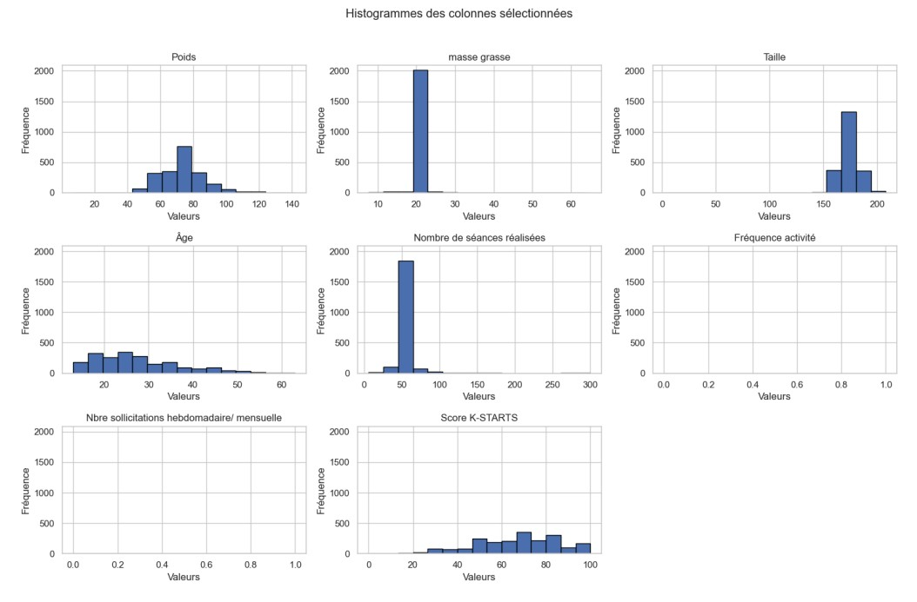

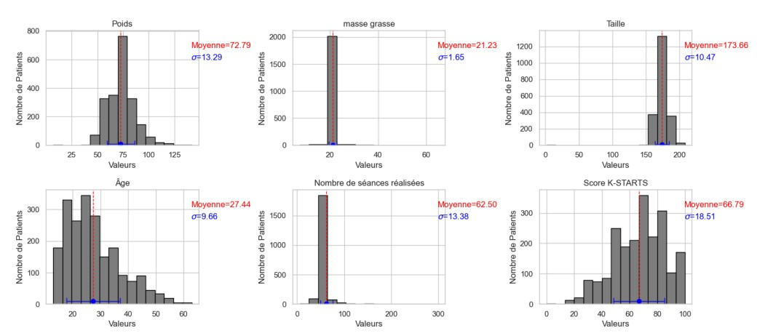

  - Heatmap: Body fat vs KSTARTS Score

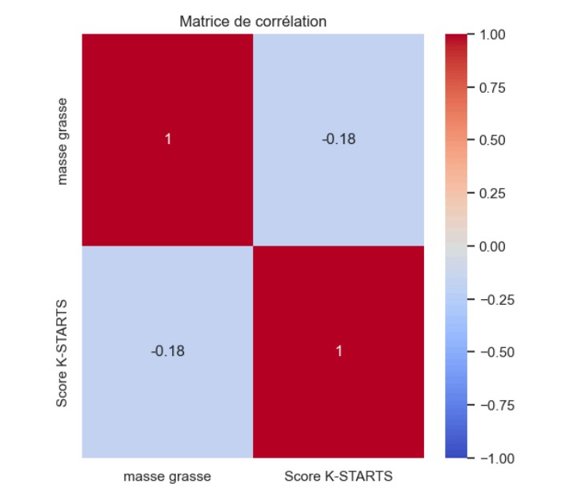

- Various scatterplots

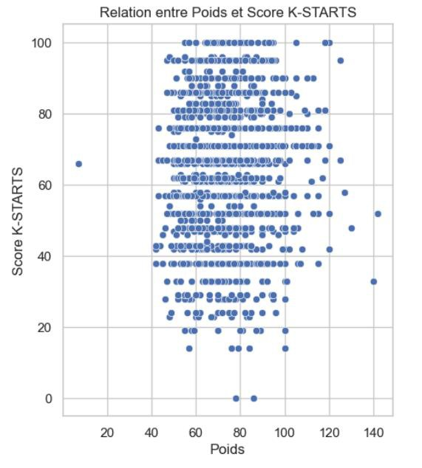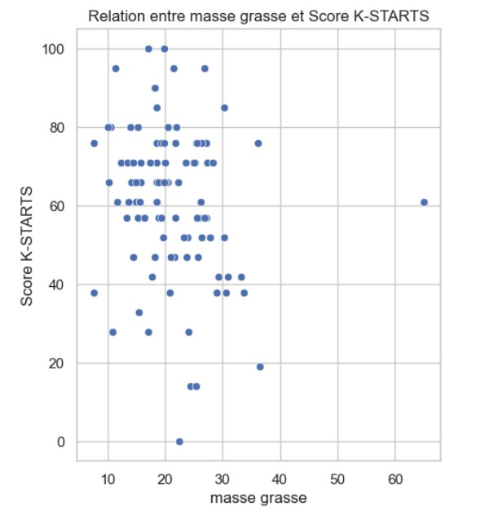

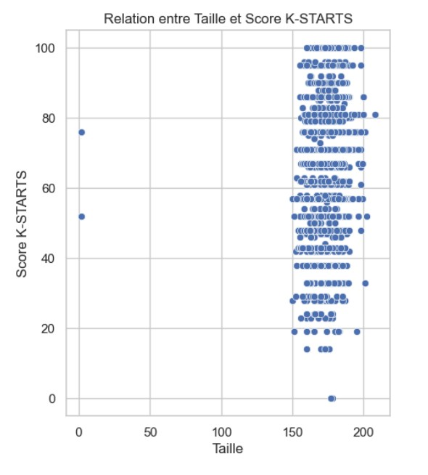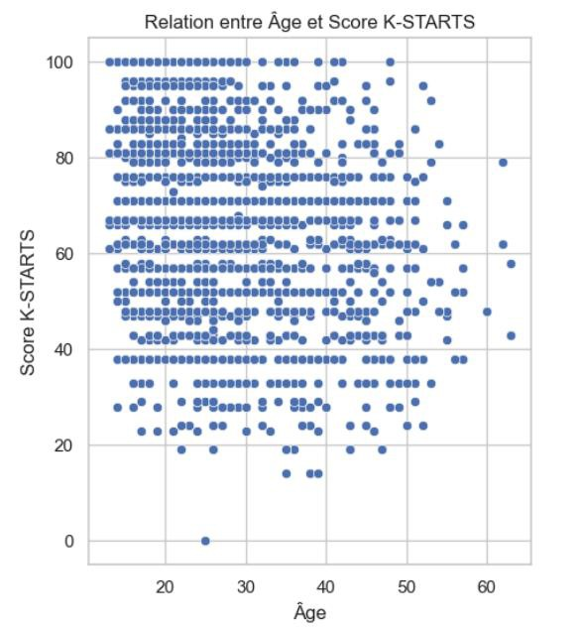

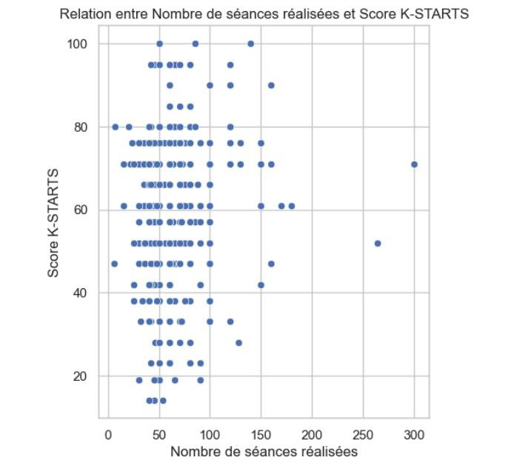

PYTHON CODE EXTRACTS
  - Statistical tests

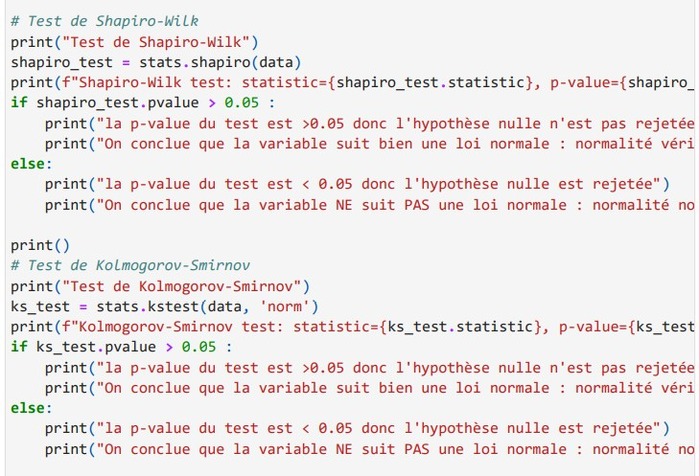

  - Correlations / régressions

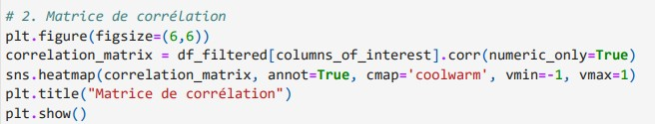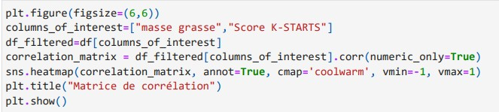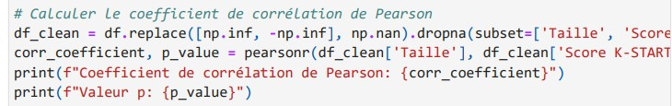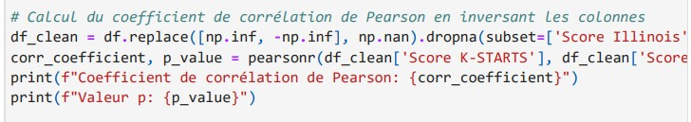

  - Visualizations

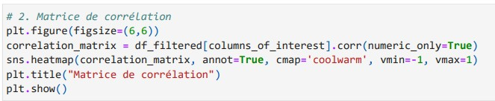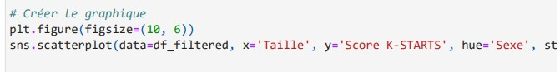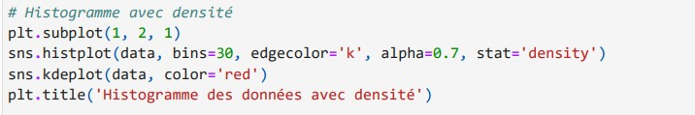

REFERENCES

“Thomas demonstrated professionalism, rigor and proactivity.” — David Laplaud, PhD, R&D Manager, Medinetic Learning

“A serious, pleasant student with strong analytical abilities.” — Pierre Guiheneuc, Physiology Professor

“Hard-working, attentive, always progressing.” — Christophe Molina, Strength Coach

CURRICULUM VITAE

